HA NOI CAPITAL, VIET NAM

3D2N

OVERVIEW

## location

Hanoi is located in Red River Delta and borders with Thai Nguyen province, Vinh Phuc province in the North; Ha Nam and Hoa Binh province in the South; Bac Giang, Bac Ninh and Hung Yen province in the East; Phu Tho and Hoa Binh provinces in the West. Hanoi sit on the right bank of Black River and both sides of the Red River, the location and terrain create favorable conditions for developing politic, economy, culture and science and it is also an important traffic hub of Vietnam.

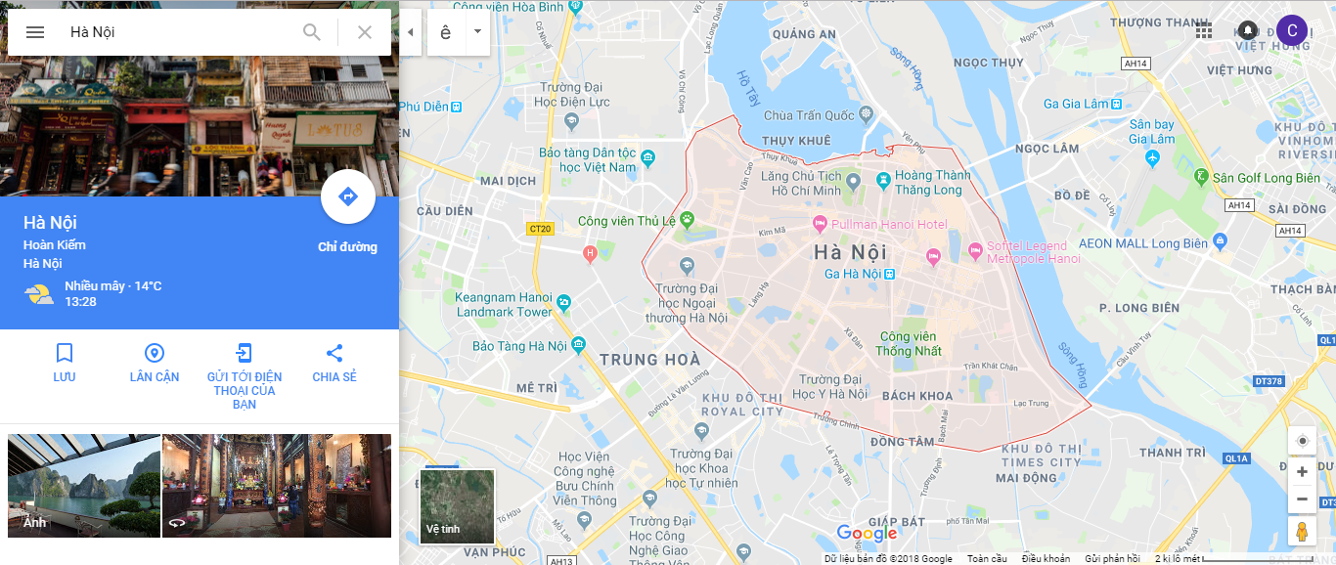

## Characteristics

Climate: The climate in Hanoi is representative for northern climate in Vietnam. The characteristics of the tropical monsoon climate are warm, hot and rainy summers, cold winters . Therefore, Hanoi has totally four seasons: Spring, Summer, Autumn, Winter. Each season has its own beauty. The best time to visit Hanoi is Autumn. The part of Ha Tay terrain (old) merged with Hanoi with its own characteristics that form the climatic regions among the mountains, hilly areas and plains. But in general, the differences between weather and temperature in current Hanoi are not too large.

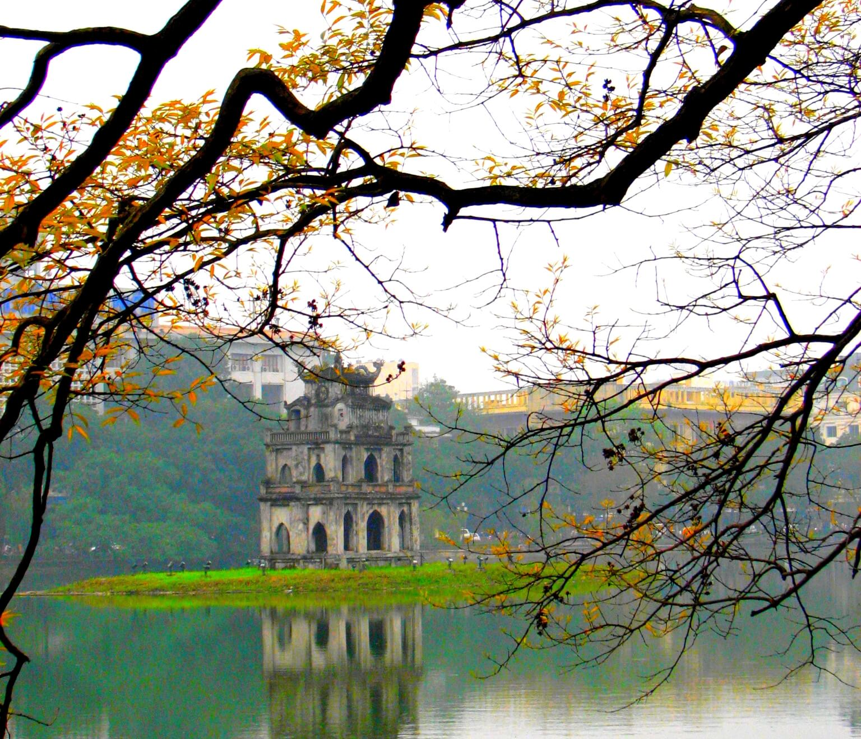

|  |  |
| --- | --- |
|  | SAI GON TO HA NOI |

## how to get to HA NOI CAPITAL

* By plane:

From Tan Son Nhat International Aiport in Saigon to Ha Noi Capital is with Noi Bai International Airport

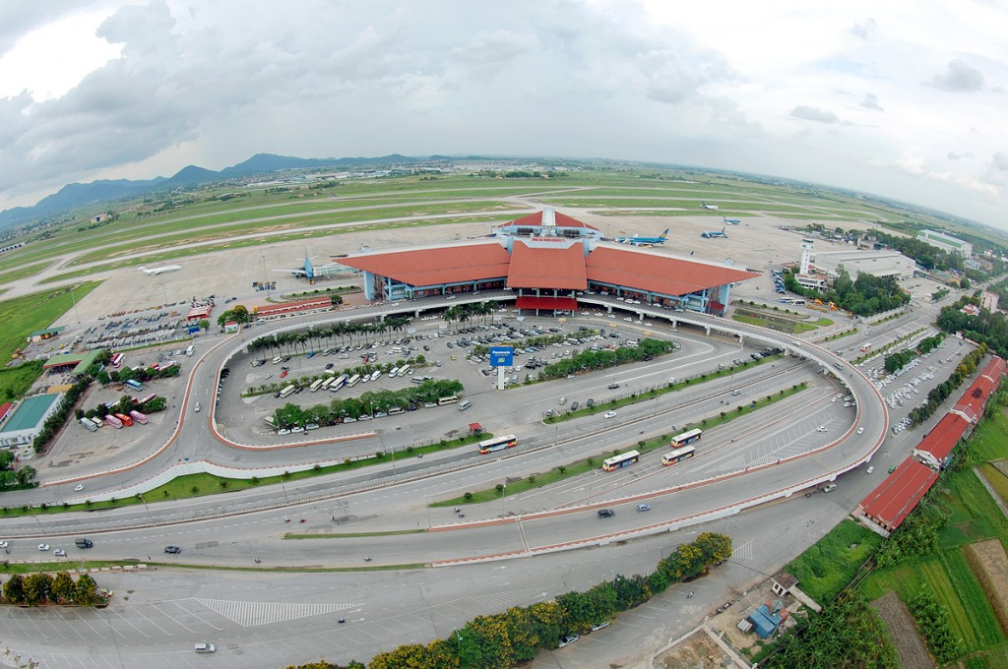

* **Egg Coffee – Morning**

If you are fascinated with Vietnamese coffee then you will love with the egg coffee. The egg coffee brings a soothing flavor for the drinker with the combination of the strong taste of coffee, the richness of the egg yolk, and the sweetness of the condensed milk. We recommend trying an egg coffee in Hanoi. Other options include lemon iced milk, beer and egg, and green bean and egg.

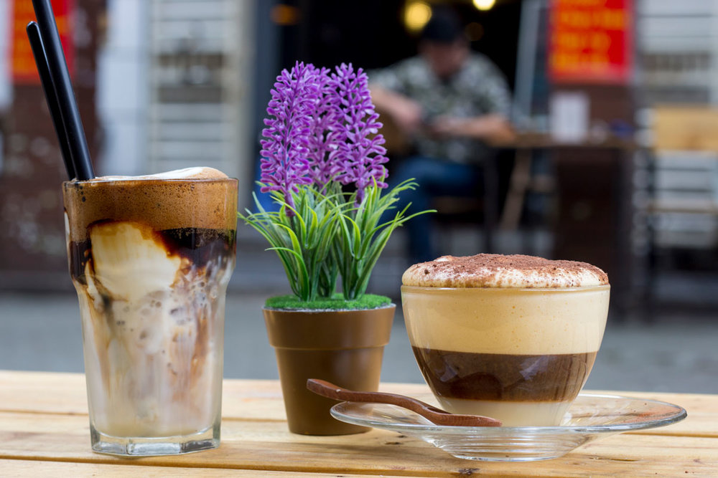

* **Hoan Kiem Lake, the Red Bridge, and Ngoc Son Temple**

Most of the wedding photo shoots are taken at this place because of the lovely atmosphere presented here. The lake has its own story behind the name Hoan Kiem Lake. Legend has it that a friend of King Le Loi found a shining metal bar when he went fishing. When this was shown to the King, he transformed the metal bar into a sword to use during battle. The King noticed that the sides of the bar had two words engraved saying “Thuan Thien” meaning “Harmonious with Heaven.” The King used this sword during his battle and won the peace. One year after winning the war and the King was riding on a Dragon boat at the lake, at that time, a golden tortoise surfaced and asked for the return of the sword. The King and the tortoise met at the center of the lake. The King threw the sword at the tortoise, who immediately grabbed the sword and went under water and was never seen again. From then the lake has become known as Hoan Kiem Lake meaning the “return of the sword lake.

|  |  |
| --- | --- |
| Hoan Kiem Lake | Red Bridge |

After visiting the lake, you should direct yourself to the east side to view the famous temple in Hanoi called “Ngoc Son Temple”. Here you will pass through the lovely gates that will lead you to the Rising Sun Bridge or Red Bridge. The bridge itself is beautifully constructed when you capture it with the water that runs around it. Walking through the bridge, you will reach the “Ngoc Son Temple.” The temple is located on Jade Island. A small fee is charged to wander around this place. It presents monuments of great heroes and legends, like Tran Hung Dao (a wartime hero), Nguyen Van Sieu, and scholar Van Xuong (Confucian Scholars).

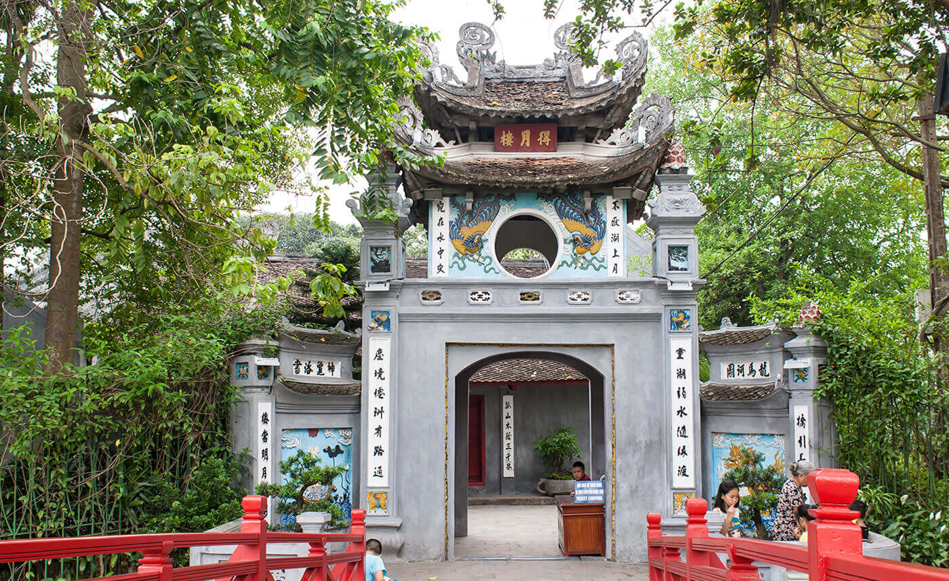

* **Hang Dau Water Tank**

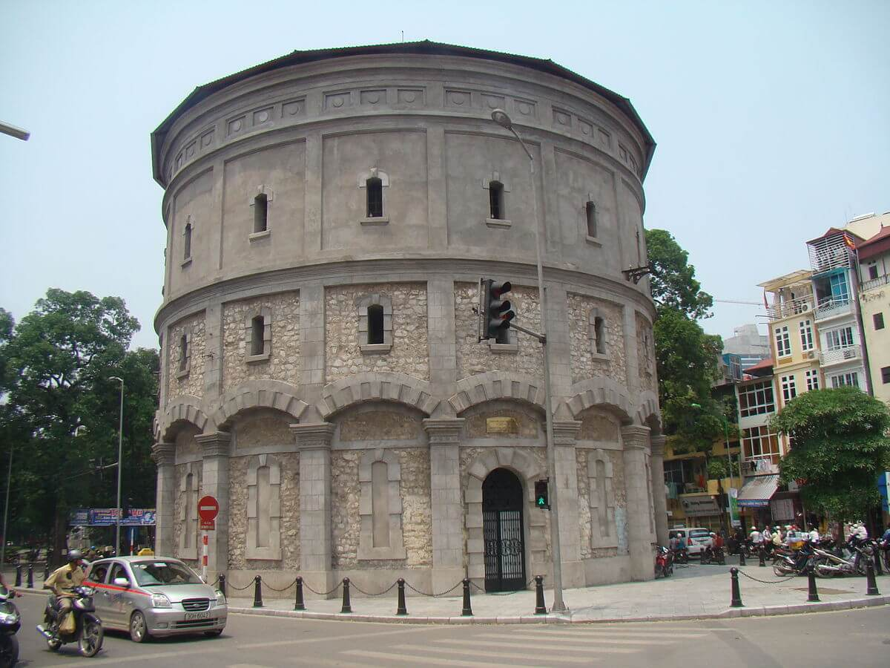

In 1894, Bot Hang Dau or Hang Dau Water Tank was built from wasted materials of Hanoi Citadel's collapse. It looks like a 3-level fortress with 25m in length. On the inner walls, there are water tanks made of corrugated iron. Each tank contains 1,250m3 of water. Water from this tank was delivered directly to the citadel where the French lived and was distributed to all the places in Hanoi. After 1954, this water tank was abandoned.

* **Flag Tower of Hanoi**

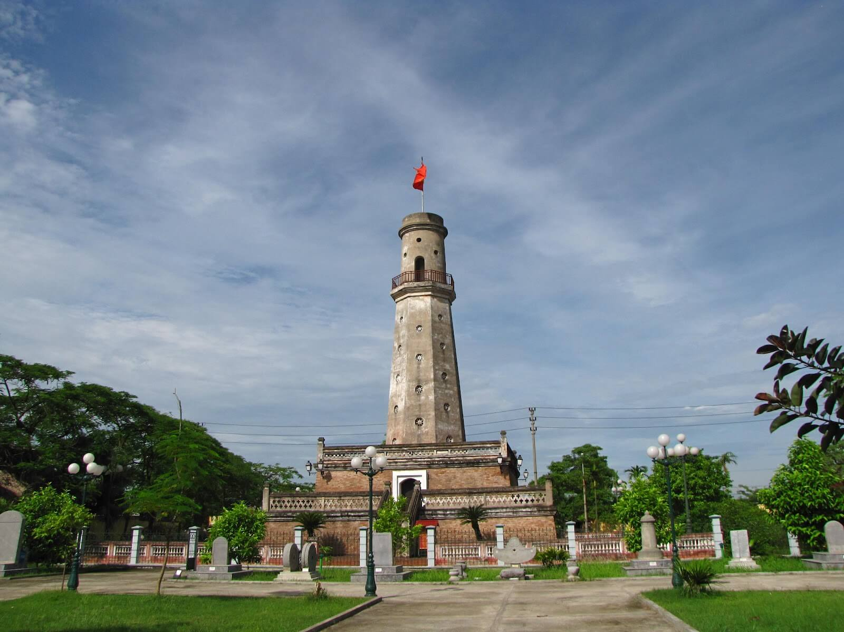

Completed in 1812, Hanoi Flag Tower is one of the symbols of Hanoi. During the period between 1894 and 1897, the majority of Thang Long Imperial Citadel was destroyed by the French, but the Flag Tower is one of the remaining architecture that still works until now. Moreover, it is interesting to note that the Bank of Vietnam issued paper money the image of the Flag Tower on October 10th, 1954 - the Capital liberation day.

* **Hanoi Ancient House**

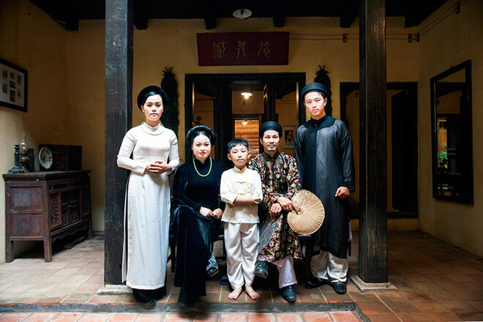

The Ancient House is one of the most attractive sites in Hanoi, built in the 20th century and restored in 1999. Although it has been renovated, visiting this place is a chance to see a historical witness of the city a hundred years ago. The house consists of a small two-block home linked together by a courtyard. Apart from the old-world style architecture, the impressive point of this building is the presentation in each room where you could see the worship culture, guest hosting room, and the living style of the Hanoians in the past. Besides, lots of souvenirs for sale are displayed on the ground floor with a broad range of collection.

**18:00 PM:** back to restaurant to have dinner and relax.

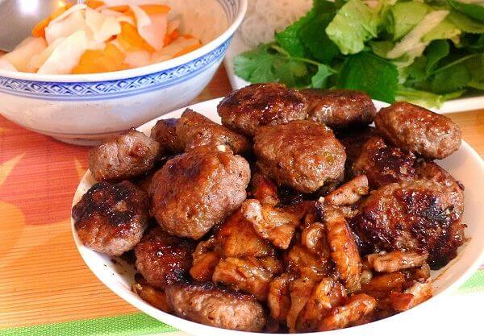

|  |  |
| --- | --- |
|  | HANOI CAPITAL |

**7:00 AM:** Depart the hotel with our tour guide.

* **Hoa Lo Museum**

Hoa Lo Prison or the Hanoi Hilton was the prison used during the French Colonization and the Vietnam War. Built by the French in 1896, it was utilized to hold the political prisoners over the period of the First Indochina War. During the Vietnam War, Hoa Lo was infamous as the incarceration for downed US pilots, who ironically nick-named it the Hanoi Hilton.

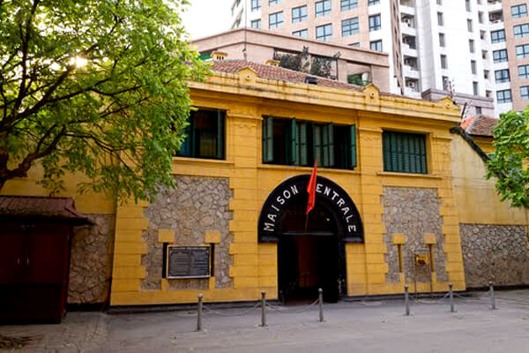

Today, this prison is preserved and has been re-created to a museum. In this building, the terrifying displays of shackles, whips, and other instruments of torture from the French-colonial are exhibited. Besides, there are some historical pieces of evidence of the Vietnamese prisons’ fighting displayed and the guillotine presented at the back of the museum. A visit to Hoa Lo Museum is important to understand more of what the people went through and sacrificed.

* **Temple of Literature**

Established in 1070, the Temple of Literature was first built to honor Confucius and celebrated the doctorates and scholars of Vietnam. In 1076, the temple was restored and used as the first university of Vietnam. In the present day, the Temple of Literature is a tourist attraction because of its typical architecture style and the underlying stories. Every year, hundreds of visitors come here to see a life-long building and discover the educational culture of Vietnam in the past.

|  |  |
| --- | --- |
|  |  |

Quan Thanh Temple

|  |  |
| --- | --- |
|  |  |

During the Ly Dynasty (1010 - 1225), the temple was built to honor “Tran Vo” the “God of the North”, who was beloved by all the local Taoists. The name “Quan Thanh” means “Place of the Gods”. It is said that this temple is a sacred place to protect Hanoi from the bad spirits and influences coming from the North direction.

* **Tran Quoc Pagoda**

Located on a small peninsula on the banks of the Red River and the East side of West Lake, this pagoda is the home of 10 shrines, including a red Buddha statue trimmed with the gold of Sakyamouni Buddha's Parinirvana, a masterpiece of Vietnamese sculpture. There are also historical relics dating back to the 1600's.

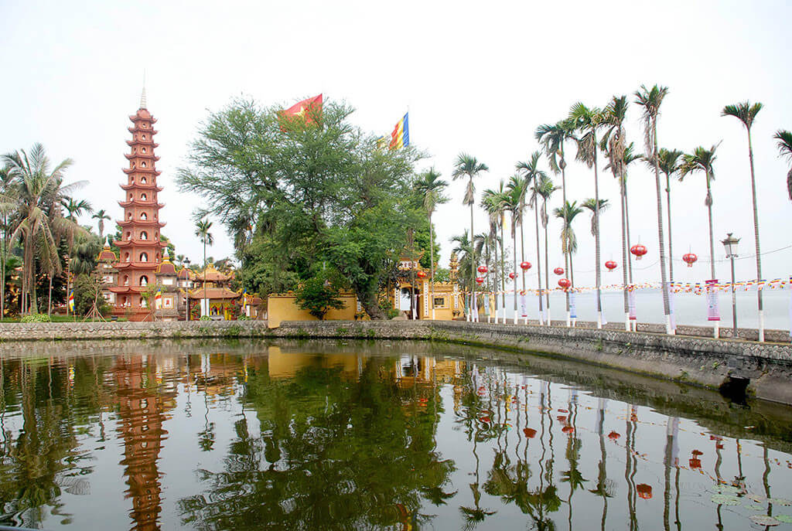

A garden and water surround the pagoda. This is the go-to pagoda if you're looking for a picturesque attraction. For a breathtaking view, visit this pagoda at sunset.

* **Ho Chi Minh Mausoleum**

The Ho Chi Minh Mausoleum dates back to 1975, and it offers a close and personal look at the sarcophagus of Ho Chi Minh himself. Plus, you'll also get a chance to see the Ho Chi Minh Museum, Ho Chi Minh’s Stilt House, and the One Pillar Pagoda all in the same complex.

Before visiting, keep in mind that you must wear formal clothes to enter. Also, note that you're not allowed to take photos inside and must show up before 10:30 AM.

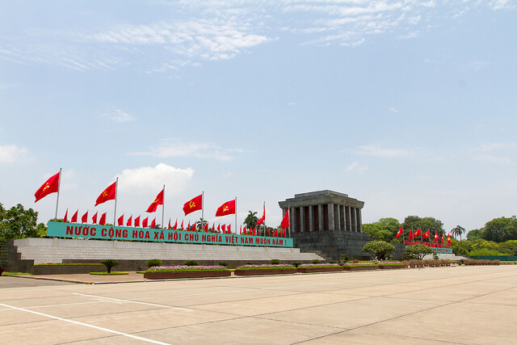

* **One Pillar Pagoda**

One Pillar Pagoda is a symbol of enlightenment. It was built to resemble a lotus flower after a dream from King Ly Thai Tong. The legend said that a Holy Lady sat on a lotus told King Ly to come up with a similar establishment. Throughout the historical horizon, although there have been several restorations to keep the most of this religious construction, it has been partly modified. Today this Pagoda is a new formed recovered in 1955 and is one of the historical symbols of Hanoi.

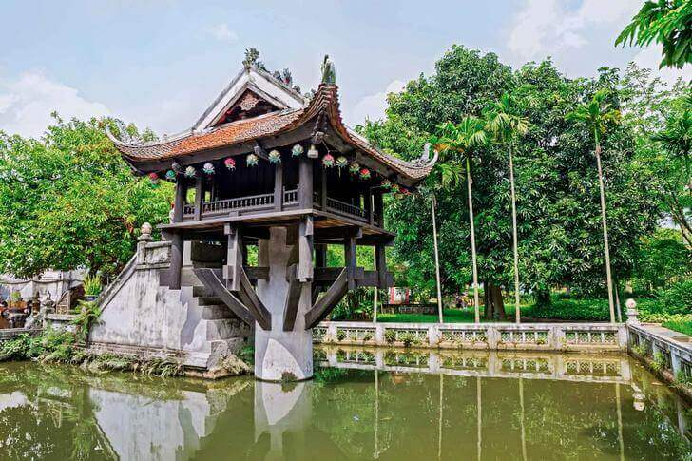

* **Vietnam Museum of Ethnology**

|  |  |
| --- | --- |
|  |  |

Unlike the majority of museums indicating the wartime, Vietnam Museum of Ethnology is a standout for any visitors looking for interesting facts about the Vietnamese. With 54 ethnic groups, Vietnamese socio-cultural diversity has caught more attention to any tourists hoping to understand the people of Vietnam. To provide all of the expected comprehension, all of the information in this museum is exhibited in a very specific way in both written and visual form. Besides, there are some interactive activities which help the visit much more enjoyable. A visit to this museum should be on your Hanoi things to do list. As this museum is located outside of the other suggestions of the third-day travel guide, you should take a taxi to get here.

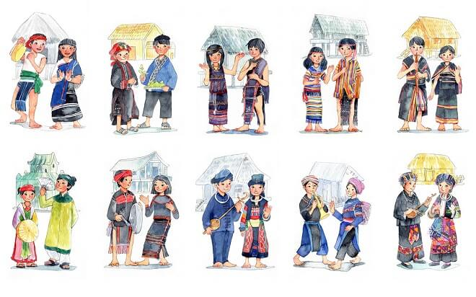

* **Thang Long Water Puppet Theater**

Water Puppet Performance is a Vietnamese traditional art date back the 11th century in the villages of the Red River Delta area, in Northern Vietnam.

The show is performed in a pool of water with main characters made from wooden puppets. The puppeteers, who stand hidden behind the screen in the water, control the puppets through the bamboo rods. The music played during the performance is live and often depicts historical event or theme. If you’re looking for relaxing things to do in Hanoi, go to the water puppet theater and enjoy a show.

|  |  |
| --- | --- |
|  |  |

**18:00 PM:** back to restaurant to have dinner and relax.

|  |  |
| --- | --- |
|  |  |

|  |  |
| --- | --- |
|  | Relax – Farewell & Goodbye |

**7:30 – 8:30 AM:** Have breakfast at the hotel.

* When ready and as your scheduled bus – train - flight allows, check out of your hotel and we’ll take you to the airport in time for your flight.
* End of Tour.

